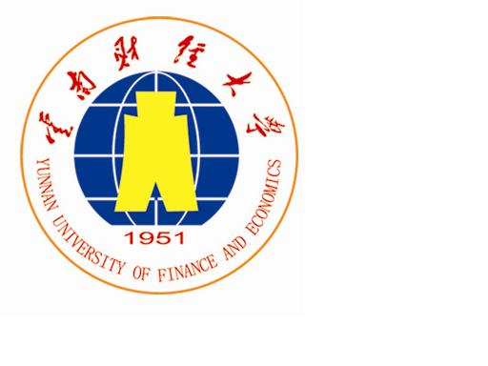 LOGO
Yunnan University of Finance and Economics **** University

MEMORANDUM OF UNDERSTANDING BETWEEN
**** UNIVERSITY
AND
YUNNAN UNIVERSITY OF FINANCE AND ECONOMICS
（Sample）

In order to enhance the educational capabilities of each of the above institutions, it is proposed that collaborations and exchanges be initiated in fields of common expertise and interest. The programs to be initiated through this MOU will be based on a spirit of cooperation, reciprocity, and of mutual benefit to both parties.

- Both institutions agree to pursue academic collaboration in various areas of education, research and extension.
- Both institutions will make good-faith and enthusiastic effort to promote program collaboration, exchange of faculty, scholars and students, as well as educational research and extension materials appropriate to the areas of collaboration.
- Students exchange program will include
(1) Non-degree Program
Short-term exchange program will be conducted and the host institution has no responsibility to award degree to exchange students.
The program targets at undergraduates or postgraduates of both institutions. However, such terms as to field of study, duration, and number of exchange students will be specified in detailed agreements.
(2) Degree Program
Both institutions will develop a long-term exchange program leading to dual degree of both institutions.
Undergraduates and post graduates of both institutions are eligible for applying.
Detailed terms regarding tuition waive, field of study, duration and number of exchange student will be specified in detailed agreement.
- Specific details of exchanges noted above will be negotiated between the institutions and specific agreement will be signed subject to the approval of each institution.
- This MOU only expresses the intention of cooperation. It has no legal effect on both parties.
- This MOU will remain in effect for five years from the date of signing, and is renewable thereafter for five-year terms subject to mutual consent. This MOU may be terminated by either party by giving at least six months notice in writing to the other party.
Yunnan University of Finance **** University
Economics, P. R. China

Signature: _________________ Signature: ____________________

Date: Date:

LOGO
云南财经大学 ****大学
Yunnan University of Finance and Economics **** University

校际合作交流备忘录
（样本）

为提升两校的教育水平，云南财经大学与**大学决定在共同感兴趣的专业领域开展合作交流。两校将本着共同合作、互惠互利的精神开展本备忘录涉及的合作项目。
- 两校同意在教学、科研和其它相关领域开展各种类型的学术合作项目。
- 两校将真诚努力推动项目合作，教师职员和学生的交流，以及学术科研和合作项目的资料共享。
- 两校的学生交换、交流项目包括：
（1）非学位项目
非学位项目的主办方无需为派出院校的学生颁发学位。
本项目针对两校的本科生和研究生，学生交换的细节，如：学科、学费、学生交换数量等将由两校签订的其他协议细化。
（2）学位项目
两校将发展长期的学生交换项目，参加本项目的学生将获得双方的学位。
两校的本科和研究生都可申请该项目。
本项目的细节，如：学科、学费、学生交换数量等将由两校签订的其他协议细化。
4. 上述事项由双方协商后，另以书面签署，并列为本备忘录之附则。
5. 本备忘录仅表达合作意向，对签署双方不具有任何法律约束力。
- 本备忘录自签字之日起五年有效，五年后经双方同意共续签。该备忘录可由任一方提前六个月书面通知取消。

中国云南财经大学 **大学

签署: ________________ 签署：_________________

日期： 日期：

